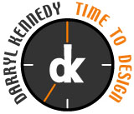
Darryl Kennedy:

Graphic – Web Designer

Portfolio Documentation
www.darrylbkennedy.com

How To Care for a Buzzard

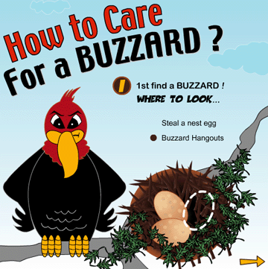

Project Introduction
How to care for a buzzard was a final student project assignment in my animation for the web (Beginning Flash) class. We had to animate “How to perform a task using illustrated instructions” I wanted to step out of the box from typical themes such as, how to change a tire or how to bake a cake that some of my classmates were using and make it unconventional and humorous by using a buzzard as the main character. The idea came while on a road trip through the desserts of Texas and New Mexico a few years ago.

Communication and Business Objectives

- Use Flash action script, drawing and animation tool to create a short animation or slide show on how to accomplish a task.
- Demonstrate working knowledge of Flash and basic action scripting

Target Audience
The target audience for this project is 13-35 year olds who enjoy gaming are pretty silly and fun by nature and enjoy wasting a few moments on the web for leisure fun.

Overall Design Approach
All images in the animation were hand drawn and my own creations. A completed storyboard was part of the assignment. I wanted the animation, colors and style to be bright, bold, smooth and clean. The style is similar to the Looney Toons and Dr Seus cartoons.

Branding and Identity
With the exception of the main buzzard character on the homepage, no branding identity was required for this student project.

Graphic Style and Typography
The graphic style approach will appeal to the 13-35 year old technology web user. Fun or simple rounded corner fonts such as Toon-time and Arial Rounded are used for the headers and titles. Both fonts are readable and fit the cartoon theme.

Interaction and links
Hand drawn cartoon arrow shaped buttons that suggest movement in bright yellow are used to navigate through the 4-movie clip animation. The user will also have the option to replay the animation form the last scene.

Accessibility Standards
The site will attempt to adhere to accessibility standards set by the Congress Section-508 Act. The use of Alt-tags on all images, disclaimers and copyright information will be placed on all pages. A full quality insurance and usability test will be performed before the final site launch.

Site Map

